
Future University in Egypt
Faculty of Computers and Information Technology
Department of Computer Science

CS 251 (Software Engineering _1 )
Summer
2024

Prepared by
ID |  | Name
 | 20223044 | Amr Sadek
 | 20223772 | Mostafa Abdelhamid
 | 20223311 | Mostafa tarek
 | 20224584 | Mohamed Walied
Supervised by
Dr. Heba Hamdy
TA. Linah Mohamed Ibrahim

Pharmacy
Wednesday/from 1 to 5
A1.3

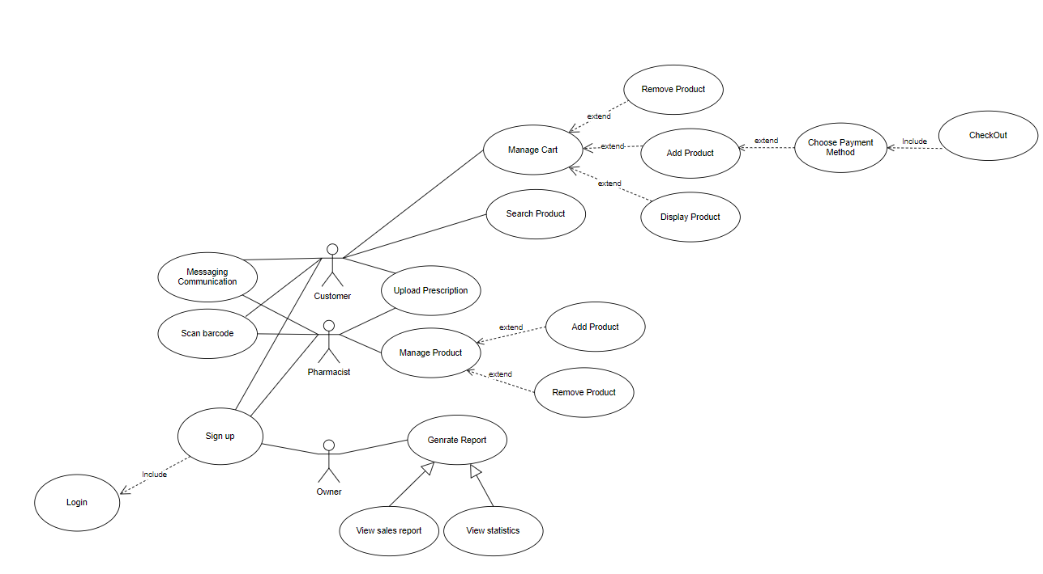
Use Case :

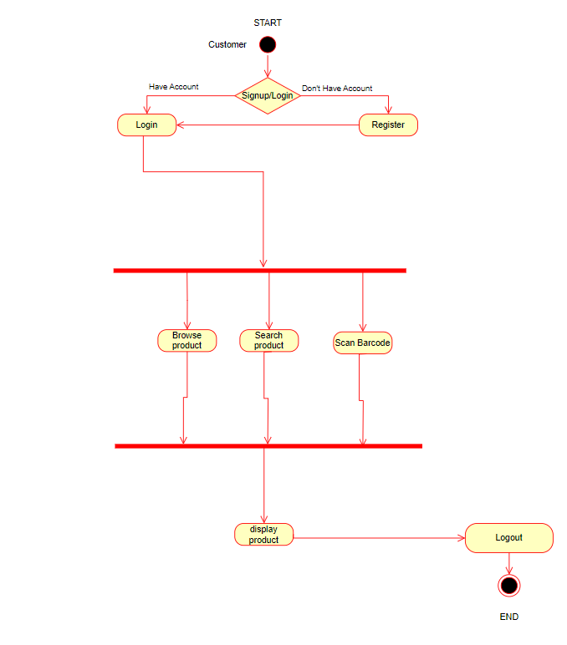
Activity Diagram :

